Assignment 1   
For a bright future for all, the United Nations has established 17 Sustainable Development Goals (UN-SDGs).  
  
  
  
  
SDG 14: Life Below Water is the topic.   
  
  
  
according to chemical and environmental indicators. This can support the conservation and sustainable use of marine resources by assisting in the identification of areas that are at danger of pollution.   
  
  
  
ocean_water_quality.csv dataset, which has columns like   
  
such as dissolved oxygen, temperature, ph, salinity, nitrate, phosphate, and a target variable water_quality that indicates if the water quality is adequate (1) or inadequate (0).

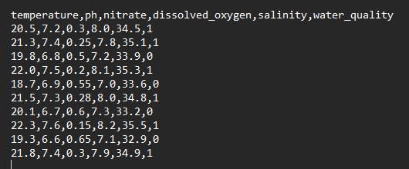**CSV DATA -**

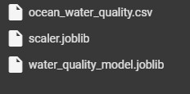

**Define Methodology and Objectives**

**• Goal: Using chemical and environmental data, create a classification model to forecast water quality.   
• Approach: Since this is a binary classification problem, we will employ models such as Random Forest and Logistic Regression.**

**Data Preprocessing**

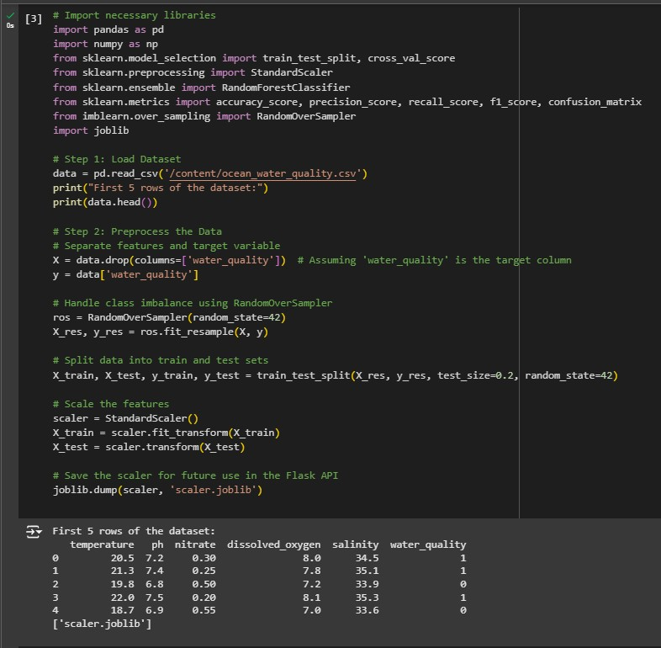

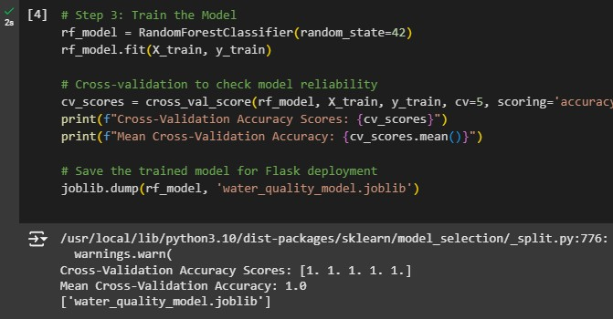

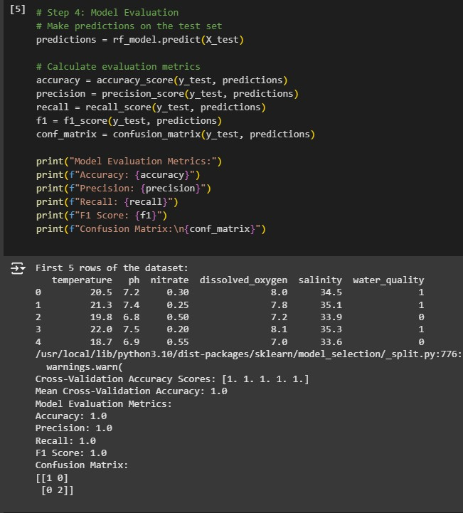

**NAME – GAJENDRA KUMAR ARYA**

**BATCH – 12**

**ROLL NO – R2142230358**

**SAP ID – 500121063**